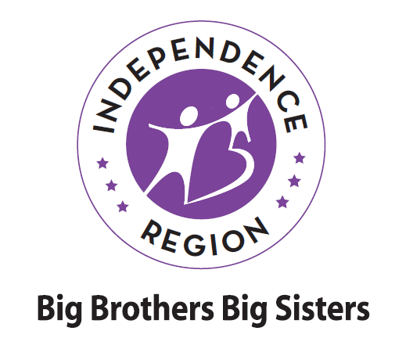
Teen Match Activity Ideas

Looking for activities to do with your teenaged Little? Try one of these options or share the list with your Little and decide what to do together. Maybe some of these options will also spark some additional ideas – whatever you do, have fun!

- Hang out at a coffee shop while you talk, play cards or games.
- Play a sport together and research its stats, players, history. Create your own fantasy ‘football/baseball, etc.’ competition or join a group together.
- Go fishing (remember to check into the requirements for a fishing license to see who needs one, before you start).
- Head out to a driving range and hit a bucket of balls.
- Practice driving with Parent/Guardian’s consent, of course, and only if your Little has a driving permit!
- Go on college tours or attend a college sporting event.
- Talk with your Little about their specific goals and help them take steps to reach them.
- Teach your Little to change a tire or the motor oil.
- Take your Little out to pick up job applications and help them with the follow through.
- Practice interview questions with your Little if they’re looking for a job.
- Build a vegetable planter and teach your Little about growing their own fruits/veggies. Cook something together with the veggies you grow.
- Teach your Little how to fix a leaky faucet, stop a toilet from running, mend a fence, etc.
- Volunteer together.
- Yard work can actually be pretty fun when you do it together.
- Make a Pinterest board together and try out “home remedies,” arts and crafts or DIY projects.
- Ongoing “old school” game competition such as chess, Backgammon, Rummy 500, etc.
- Learn to cook new foods together – make your own cookbook and include all the recipes you’ve tried together.
- Make it your mission to find the best burger or pizza in town.
- Take your Little along when you vote.
- Attend a free concert.

